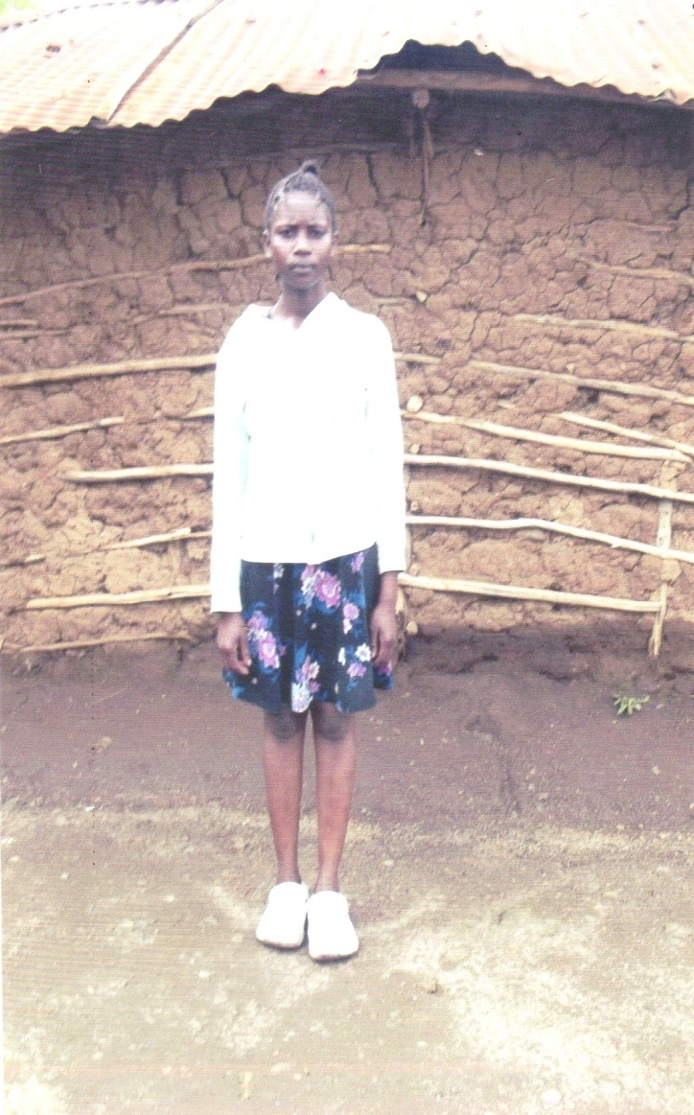 | Name: |  | PURITY ONDISO ONYANGO
 | Age: |  | 16 YEARS
 | DOB: |  | 09/02/2007
 | Place of Birth |  | KISUMU
 | Health: |  | GOOD
 | Name of School: |  | JEHOVAH JIRE SEC SCH
 | Grade: |  | B+
 | School Attendance: |  | 50/50
 | Parent Information
 |  | Father |  | Mother | Guardian
 | Name: | N/A |  | MIRIAM AMADI ONYANGO
 | Age: | N/A |  |  | N/A
 | DOB: | N/A |  |  | N/A
 | Address: | N/A |  |  | N/A
 | Occupation: | N/A |  |  | N/A
 | Income: | N/A |  |  | N/A
 | Education: | N/A |  | PRIMARY | N/A
 | Health: | N/A |  | GOOD | N/A
 | Relation: | FATHER |  | MOTHER | N/A
 | Siblings: | DOB: |  | School Level | Health Status
 | GEORGE O.O | 25/96/2009 |  | GRADE 6 | GOOD
 | DERICK O.O | 07/07/2012 |  | GRADE 4 | GOOD
Roskern Foundation Child’s Profile Case Study Review:
Purity Ondiso Onyango is a daughter of Miriam Amadi Onyango and the late Edwine Onyango Orimbo. Purity is the first born in the family of three. Purity’s Father died in the year 2016 when she was nine years old. From that time the mother has been struggling in raising the three children single handedly. The life has not been easy from all the aspects and this made the mother to take her to a local school in the village where she walks for almost 3 hours before reaching the school.
During her trips to school, Purity faces a lot of challenges being the girl child, the girl is being harassed by boys on her way to school and this instill fear in her. Purity is a hardworking girl but due to challenges back at home, she feels low when going to School. Sometime there is no food at home, no fuel for studies, poor environment (too much drunkenness) all those challenges still make her not to do much in her academics, but still topped in her class.
I therefore appeal to any well wisher who can assist Purity to achieve her dream in education since she does well in her academics despite of all that she goes through so that she can change the family status.
Case Review done by Simba.

Sponsorship Partner:______________________________________________________
Address: _____________________________________________________________
Phone Numbers: Home: ____________________ Cell: ________________________
Email Addresses: ______________________________________________________
Amount Given In Support: ______________

