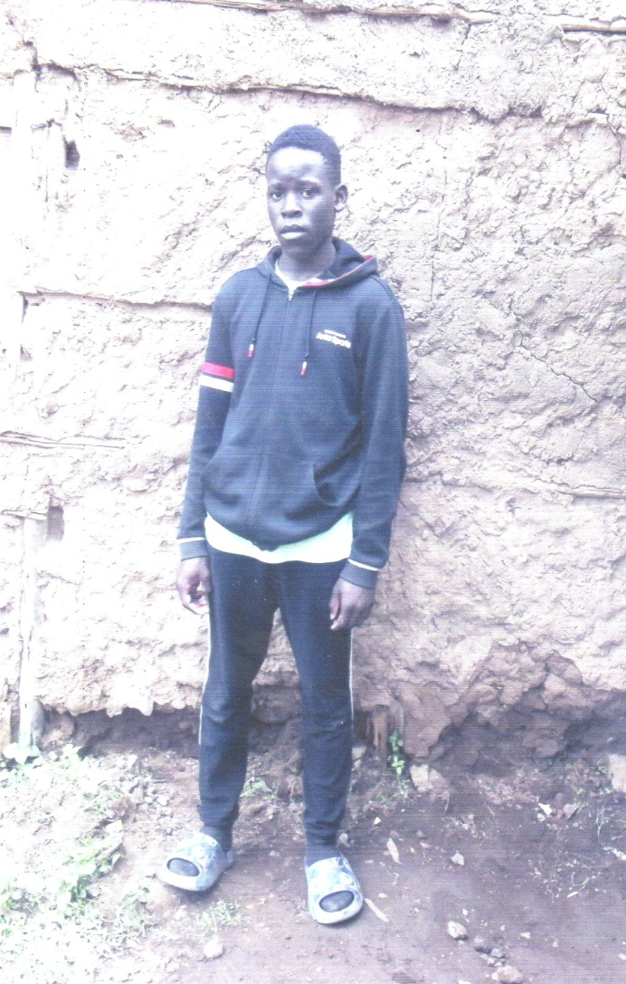 | Name: |  | JAMES OGONDA MUGA
 | Age: |  | 14 YEARS
 | DOB: |  | 12/ FEB/ 2009
 | Place of Birth |  | PROVIDE MATERNITY HOSP
 | Health: |  | GOOD
 | Name of School: |  | KING BARACK SEC SCH
 | Grade: |  | B
 | School Attendance: |  | 50/50
 | Parent Information
 |  | Father |  | Mother | Guardian
 | Name: | N/A |  | EVALYNE.A. AUMA | N/A
 | Age: | N/A |  | 46 | N/A
 | DOB: | N/A |  | 01/07/1977 | N/A
 | Address: | N/A |  | SIAYA | N/A
 | Occupation: | N/A |  | NO | N/A
 | Income: | N/A |  | NO | N/A
 | Education: | N/A |  | O LEVEL | N/A
 | Health: | DEAD |  | GOOD | N/A
 | Relation: | FATHER |  | MOTHER | N/A
 | Siblings: | DOB: |  | School Level | Health Status
 | PEREZ A. O | 10/12/1998 |  | A LEVEL | GOOD
 | NELSON.O.O | 24/07/2000 |  | A LEVEL | GOOD
 | EASTHER A. O | 04/09/2002 |  | A LEVEL | GOOD
 | RICHARD O.O | 24/11/2013 |  | GRADE 5 | GOOD
Roskern Foundation Child’s Profile Case Study Review:
James Oganda Muga is the son of Evalyne Anyango Otieno and the late Erick Otieno. James is the fourth born of a family of five. James father died in the year 2017, and since then the life has never been the same again because the mother was just a house wife. There has been a lot of challenges in the family since the mother is just washing for people to make ends meet.
The siblings also dropped out of school because of lack of school fees. Educating James also has been a problem. He has been off and on in school but despite of all those challenges, he still made it to be among the top ten in their school. James is an outstanding child all round that if he can be given a chance in education can change the family/Society in the future.
Since James lives in the slums in the outskirts of Nairobi, the environment also affects his moral behavior. If given a chance to go to boarding school, it can be of great help to him.
I therefore appeal to anyone who could give an assistance to the boy, that it would be highly welcomed and highly appreciated in advance.
Case Review done by Simba.

Sponsorship Partner:______________________________________________________
Address: _____________________________________________________________
Phone Numbers: Home: ____________________ Cell: ________________________
Email Addresses: ______________________________________________________
Amount Given In Support: ______________

